**CHAPTER II**

**Theoretical Framework and Review of Related Studies**

**2.1 Theoretical / Conceptual Framework**

**INPUT PROCESS OUTPUT**

Knowledge Requirements

* MySQL, HTML, JavaScript, PHP, CSS, C#, SSL

Software Requirements

* Sublime Text
* Microsoft Visual Studio 2015
* Adobe Photoshop
* Windows 7 up
* Any Web Browser
* XAMPP
* myasp.net (Hosting)

Hardware Requirements

* RAM 4GB or Higher
* Intel Core i3 or Higher
* Minimum of 250GB of HDD or Higher
* GSM USB dongle
* DigitalPersona USB Fingerprint Scanner

Online Patient Portal with Secure Socket Layer, Scheduling and Human Resources Forecasting

Methodology Agile System Development Life Cycle

* Concept
* Inception
* Construction
* Transition
* Production
* Retirement

Development of System

* GitHub
* Stock overflow
* W3schools
* Tutorial Points

Development of System

* System and Database Installation

**FIGURE 2-1 Input-Process-Output**

The system has been developed as a local system on a client side server platform is Windows. This combination is ideal for these are products of Microsoft. .NET for the client-side programming uses C# and MySQL Database for Online and Local System. In the Online based web application for a patient scheduled appointments, the proponents will be using PHP, JavaScript, HTML as the scripting of the system’s front-end and MySQL Server acts as the Online Database.

**2.2 Review of Related Studies**

**e-therapy.com.au by Silvertrees Web Development**

Review for this Study shows that the “E-treatment” framework enables customers to enlist and select from a scope of various specialists on the web. The E-treatment offers adaptability to the customers, and it permits customers to book a secure online talk session.

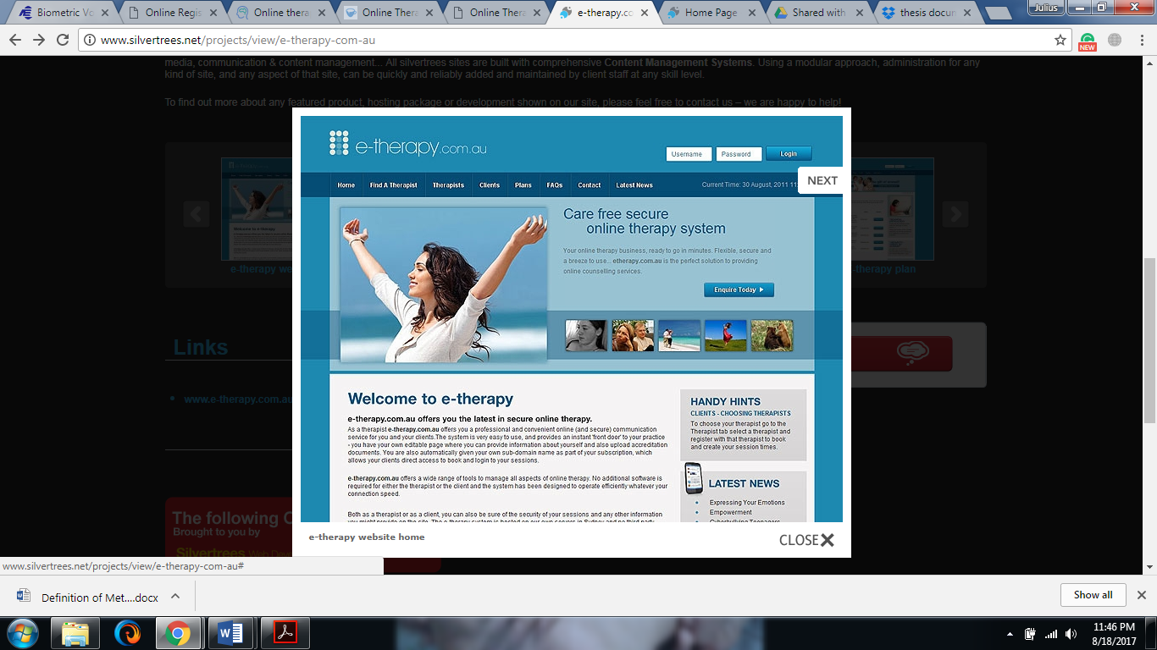

Figure 2-2 e-therapy Home Page

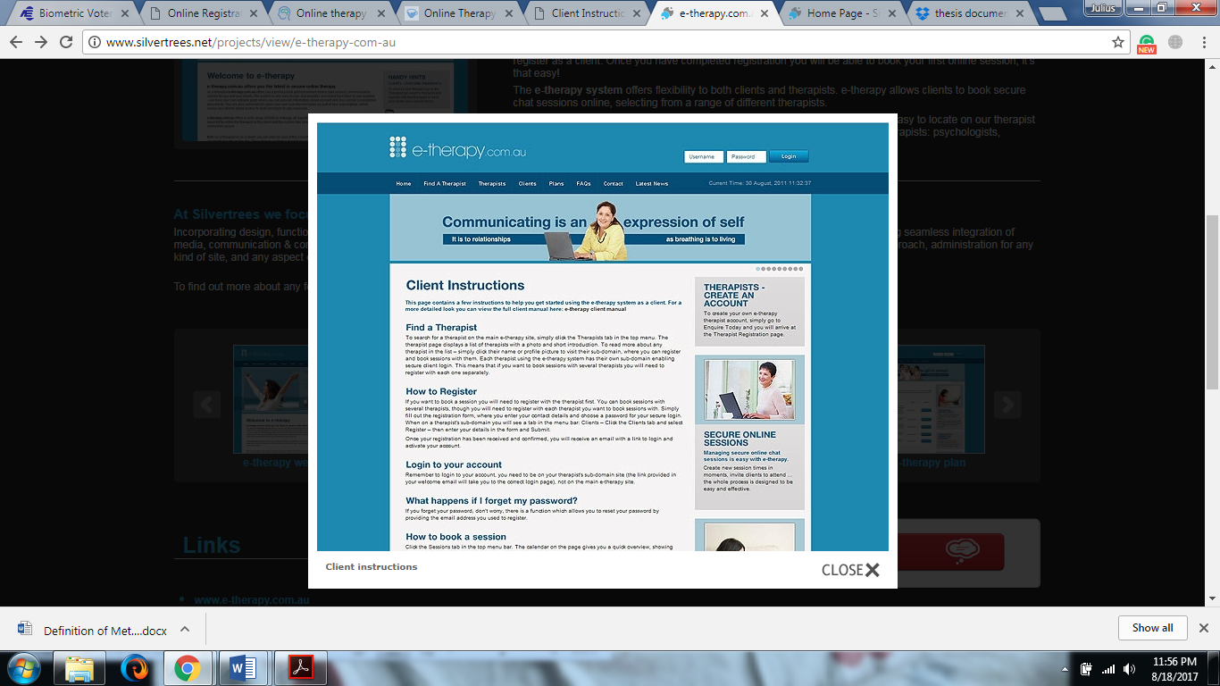

Figure 2-3 Client Instruction Page

The E-therapy system was created to have an easy and convenient online communication service for therapist and the clients. In the Instruction Page, the Client will be told know how to register an account and to Find a Therapist that will in his or her their health condition.

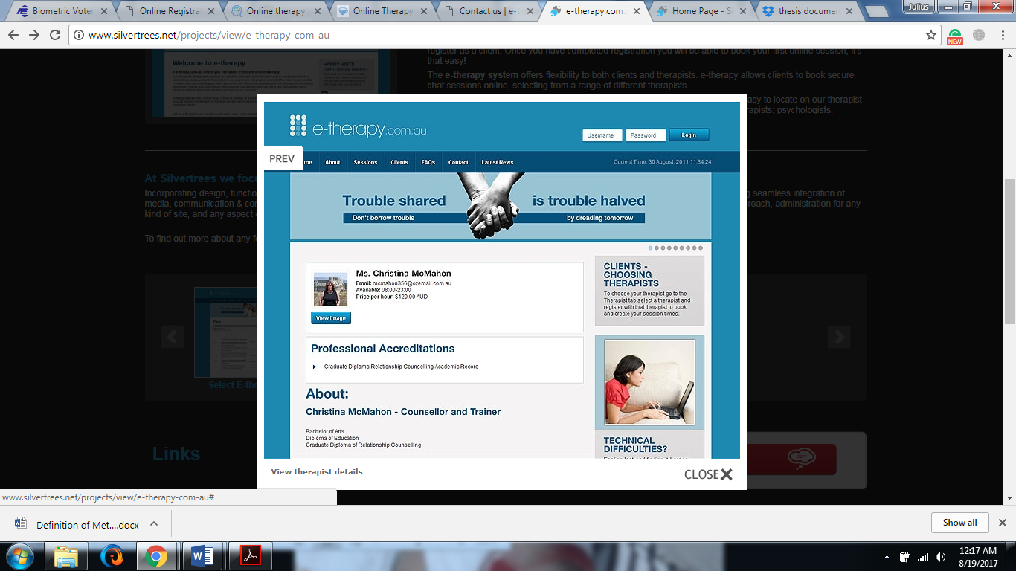

Figure 2-4 Therapist Details Page

In the Therapist Details Page, the client can view information about the Therapist like Personal information, Professional Accreditations, etc. The client can also request and book a session with the Therapist.

**wecounsel.com**

The “wecounsel” system helps to providers to use telemedicine in their practices through an advanced cloud-based communication technology, such as HIPAA-compliant video conferencing, secure messaging, and Instant Chat. Telemedicine also helps mental health providers to widen their reach to patients in a cost-effective manner for a greater continuum of care.

Telemedicine allows health care professionals to evaluate, diagnose and treat patients at a distance using telecommunications technology. The approach has been through a striking evolution in the last decade and it is becoming an increasingly important part of the American healthcare infrastructure. [[CHIR2017](https://chironhealth.com/telemedicine/what-is-telemedicine/)].

HIPAA is the acronym for the Health Insurance Portability and Accountability Act that was passed by USA Congress in 1996. HIPPA provides the ability to transfer and continue health insurance coverage for millions of American workers and their families when they change or lose their jobs. It reduces health care fraud and abuse. In addition, the Act also mandates industry-wide standards for health care information on electronic billing and other processes. Lastly, it requires the protection and confidential handling of protected health information. [[DHCS2017](http://www.dhcs.ca.gov/formsandpubs/laws/hipaa/Pages/1.00WhatisHIPAA.aspx)]

The “wecounsel” system meets these HIPAA requirements and is used by health clinics as a supplement to the clinic’s in-person services and for clients who struggle to make it to the center regularly. It is also used by Specialty Service Providers like InSight and MedOptions. InSight is a leading behavioral telemedicine services company. It conducts the nation’s highest number of virtual psychiatry sessions. MedOptions is the United States of America’s leading provider of behavioral health services to skilled nursing and assisted living facilities.

The system also has security features such as Password Management Systems and Session Time-Out to protect the important information of the users. It also employs 256-bit AES encryption and passwords that are stored and transmitted must be in protected (e.g. encrypted or hashed) form.

**yellowschedule.com**

Based on the review of the system, “yellowshcedule” is was being used as an online appointment scheduler for a therapist and his or her clients. The system enables fast and secure online scheduling of appointments by allowing the clients to book their own appointments anytime they want through online and it uses SHA-256 to encrypt the client’s data.

The systems also used SMS & Email reminder that automatically reminds clients about their scheduled appointment. It also has a response gathering that allowing the Therapist and their clients to see at a glance who has confirmed and who has canceled an appointment. This eliminates guesswork and enables the Therapists to rebook vacant appointment slots.

The appointment-scheduling process, historically viewed as a necessary burden in medical offices, healthcare facilities and wellness centers can be completely automated through an efficient online scheduling software program. The benefits of implementing this technology touch everyone involved in the scheduling process, as administrators and staff can conduct their tasks more efficiently and accurately, while customers and clients have the ability to book their appointments and reservations quickly and more conveniently. [[APPO2012](https://www.appointment-plus.com/images/pdf/online-appointment-scheduling-benefits-to-medical-healthcare-wellness.pdf)]

**appointmentreminder.org**

Based on the study, proponents learned that the “appointment-reminder” system is an online scheduling appointment and reminder system that is being used by personal services and professional services industries like law firms, auto repair business, healthcare, etc. It uses Short Messaging Service (SMS) and Email notification to automatically remind their clients for their scheduled appointments. The system increase revenue by saving appointments by means of giving clients reminders shortly in advance of their appointment, thereby decreasing no-shows and, when a cancellation is unavoidable, giving the therapist enough time to book an appointment with a different customer for the freed time.

In today's competitive world, differentiation is a significant factor in the success of the service provider. Once the basic services, such as voice telephony, are deployed, SMS provides a powerful vehicle for service differentiation. If the market allows for it, SMS can also represent an additional source of revenue for the service provider. The benefits of SMS to subscribers center around convenience, flexibility, and seamless integration of messaging services and data access. From this perspective, the primary benefit is the ability to use the handset as an extension of the computer. SMS also eliminates the need for separate devices for messaging because services can be integrated into a single wireless device- the mobile terminal. These benefits normally depend on the applications that the service provider offers. [[EDUC2017](http://educypedia.karadimov.info/library/SMS.pdf)]

**Biometrics and Healthcare**

Rawlson O`Neil King Lead Researcher, Biometrics Research Group, Inc. has come out with a new idea for integration of biometrics in to the Healthcare Industry, using Biometrics as a validation for staffs and patients to avoid from health care fraud and improve patient privacy and health care safety.

This provides ideas to the proponents by showing that Biometrics can be used as a primary way of security authentication instead of passwords, tokens, cards, and PINs. It can be also make for improved workflow by using fingerprint biometric authentication. Research for the Study showed that password resets and managing token, card and PIN programs include subtle hidden and recurring costs, which in time, become significant. They also bear intrinsic risk factors such as the ability to be lost, stolen or shared; unlike any biometric solution.

Since inefficiency and fraud are overriding administrative concerns for health care systems, especially in the United States, increased investment in health care security protocols that involve biometrics can be expected. Adoption of “health care biometrics” will mainly take place in hospitals, clinics, and other facilities. In terms of workflow, these tools will protect health care resources and medical data. Concerning patients, biometric systems will be used for patient identification. While small-scale implementations will be used initially in the United States, it is to be expected that large-scale patient identification systems will be rolled out in emerging and developing countries [[RAWL2015](http://www.biometricupdate.com/wp-content/uploads/2015/02/Biometrics-in-Healthcare.pdf)].

**Quantitative Methods in Health Care Management**

The improvement of the system management and processes that provide health care must rely on quantitative tools, specific methods that can help managers analyze, design and implement organizational changes to achieve efficiency as well as high quality of care (effectiveness) for the patient.

According to the U.S Department of Labor statistics shown in the table below, growth in health care management positions is projected to be slightly higher than in all heath care occupations. The changes in the health care industry will continue and will affect the delivery of health services in terms of cost and efficiency as well as the quality of care [[YASA2005]](https://books.google.com.ph/books?hl=en&lr=&id=zPeCLkDcIlAC&oi=fnd&pg=PR3&dq=health+care+forecasting+analysis+monthly&ots=NVl-EWL3op&sig=8Q5Og0M4p2l2RNXJqz1_MDr3XZc&redir_esc=y#v=onepage&q&f=false).

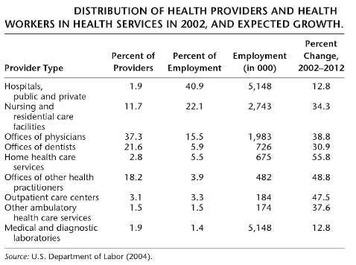

**Demand Planning and Forecasting**

Base on the research, planning according to demand would reduce the wasted and unused provider resources and the opportunity cost of patient’s time. Using demand analysis does not mean that medical need is disregarded. Instead, additional demand factors, as well as need, are used to estimate utilization. Once demand has been forecast (by type of facilities, health manpower, etc.), it can be decided, based on value judgements, whether supply should be increased or decreased. Shortages of facilities and manpower are costly because they waste a patient’s time that could have been spent in a more productive manner [[PAUL2012].](https://books.google.com.ph/books?hl=en&lr=&id=-XEJAAAAQBAJ&oi=fnd&pg=PT7&dq=forecasting+in+health+care+using+quantity&ots=u9PQPRg7Bc&sig=P5Ep4eGm9-h-oXXrsaHoxbfKxJo&redir_esc=y#v=onepage&q=forecasting%20in%20health%20care%20using%20quantity&f=false)

**2.3 Operational Definition of Terms**

SQL – Stands for Standard Query Language. A query language used for accessing and modifying information in a database [[ITBE2017]](http://www.sqlcourse.com/intro.html).

MySQL – A full-featured relational database management system (RDBMS) that competes with the likes of Oracle DB and Microsoft’s SQL Server. MySQL is sponsored by the Swedish company MySQL AB, which is owned by Oracle Corp. However, the MySQL source code is freely available because it was originally developed as freeware. MySQL is written in C and C++ and is compatible with all major operating systems. [[TECH2017](https://www.techopedia.com/definition/3498/mysql)]

HTML – Stands for Hyper Text Markup Language. HTML is a computer language devised to allow website creation. These websites can then be viewed by anyone else connected to the Internet [SHAN2012].

CSS – Stands for “Cascading Style Sheet.” Cascading style sheets used to format the layout of Web pages. They can be used to define text styles, table sizes and other aspects of Web pages that previously could only be defined in a page’s HTML [CHRI2006b].

C# – Stands for designed to work with Microsoft's .Net platform. Microsoft's aim is to facilitate the exchange of information and services over the Web, and to enable developers to build highly [portable](http://searchstorage.techtarget.com/definition/portability) applications. C# simplifies programming through its use of Extensible Markup Language ([XML](http://searchsoa.techtarget.com/definition/XML)) and Simple Object Access Protocol ([SOAP](http://searchsoa.techtarget.com/definition/SOAP)) which allow access to a programming [object](http://searchsoa.techtarget.com/definition/object) or [method](http://searchcio-midmarket.techtarget.com/definition/method) without requiring the programmer to write additional code for each step [[MARG2007].](http://searchwindevelopment.techtarget.com/definition/C)

PHP – Stands for "Hypertext Preprocessor." (It is a recursive acronym, if you can understand what that means.) PHP is an HTML-embedded Web scripting language. This means PHP code can be inserted into the HTML of a Web page. When a PHP page is accessed, the PHP code is read or "parsed" by the server the page resides on [[TECH2017].](https://techterms.com/definition/php)

BIOMETRIC – Biometrics refers to technologies used to detect and recognize human physical characteristics. In the IT world, biometrics is often synonymous with "biometric authentication," a type of security authorization based on biometric input [[TECH2017].](https://techterms.com/definition/biometrics)

SMS – Stands for short message service It's a way to send short, text-only messages from one phone to another. These messages are usually sent over a cellular data network [[SAMC2017]](https://www.lifewire.com/what-is-sms-mms-iphone-2000247).